https://infinity-ten-psi.vercel.app/ website link
www.infinityoverseasconsultant.com
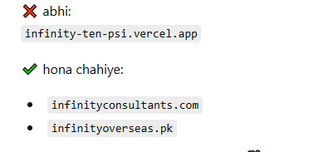

Email ?



Client Interviews
Success stories – suceesful visas- acceptance letter (watermark)- Ielts /PTE RESULTS
BLOG – OWN- BLOGGER WEBSITE
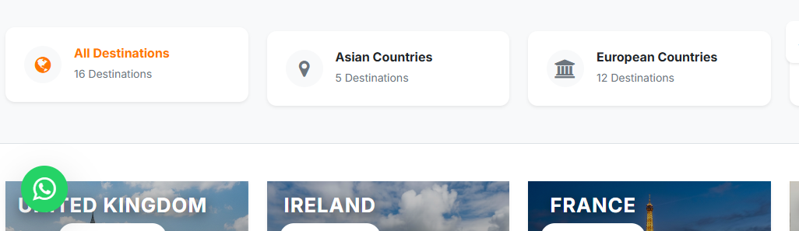

ALL DESTINATIONS??

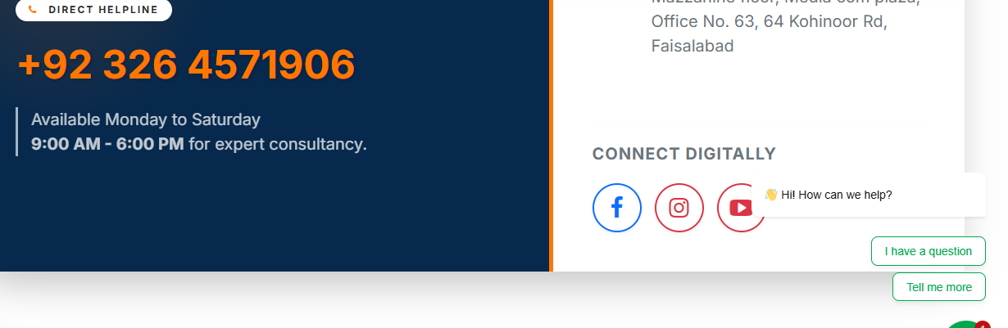

Expert Advice Just One Call Away!
Speak with Our Experts – Contact Us Now
FB,INSTAGRAM,LINKEDIN,YOUTUBE LINK MISSING
Pre-Departure Guidance
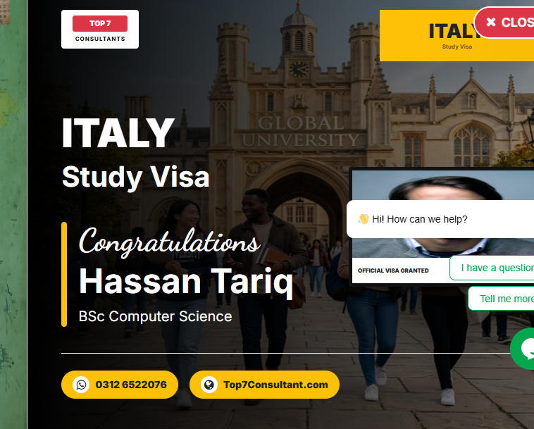
Testimonial???? Why top7 in our brand???
Highly professional consultancy. They helped me choose the right university and supported me throughout."
– Sara Ahmed, Australia

Subscribe?

